**PROJECT (Data Analysis – SQL SEVER)**

**PROJECT NAME:** **COOKIES SALES ANALYSIS**

--write an sql query to retreive all the columns from the customer table

select * from Customers;

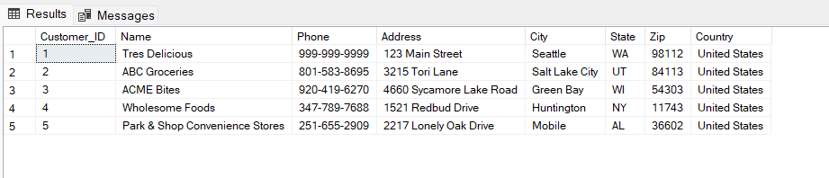

-- How many rows are there in the "cookiesTypes" table.

select count(*) 'Total Rows' from [Cookie Types];

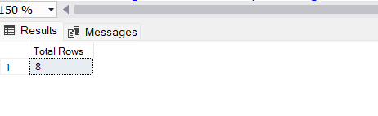

--what is the maximum number of units sold for a single order in the 'orders' table.

select max(units_sold) as Maximum_amount from orders;

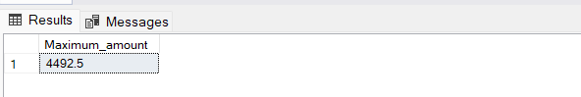

--retrieve the names and phone numbers of customers who are located in the USA.

select name,Phone from Customers

where Country = 'united states'

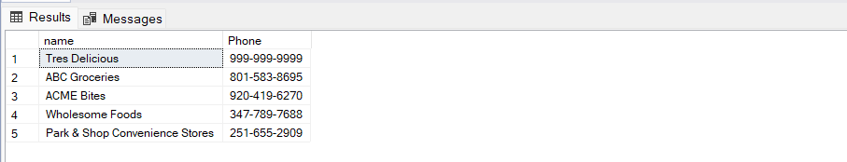

--Calculate the total revenue generated from all the orders.

select sum(revenue) as 'Total Revenue' from orders;

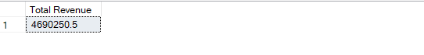

--list the top 3 cookie types based on the revenue per cookie(desc)

select top 3 Cookie_Type ,Revenue_Per_Cookie

from [Cookie Types]

order by Revenue_Per_Cookie desc

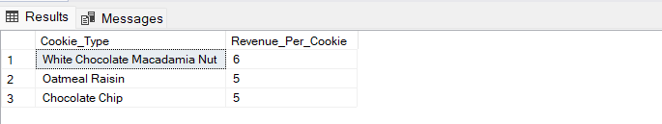

-- write a query to get the names and addresses of customers who ordered 'Chocolate Chip' cookies.

select c.name,c.address

from customers as c join orders as o

on c.Customer_ID = o.Customer_ID

where o.product = 'chocolate chip';

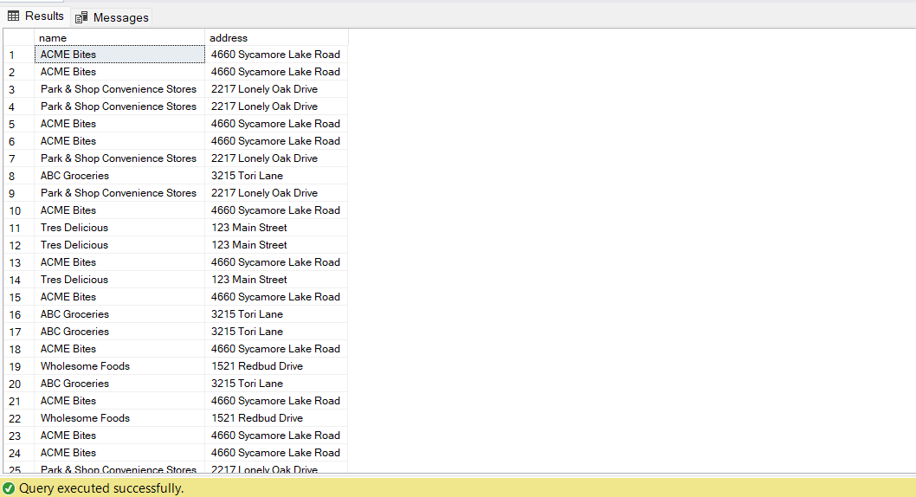

--Calculate the total cost incurred for each product and display the result in asending order of the cost

select product,sum(cost) as 'Total Cost'

from orders

group by product

order by [Total Cost] desc;

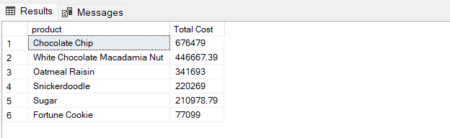

--find the average revenue per cookie for all the cookie types.

select Cookie_Type,avg(revenue_per_cookie) as Avg_revenue

from [Cookie Types]

group by Cookie_Type

order by Avg_revenue desc

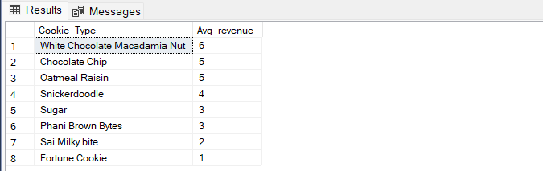

--list the customer names and order dates for orders with a profit of more than $500

select c.name,o.date ,o.Profit

from Customers c join orders o

on c.Customer_ID = o.Customer_ID

where o.profit > 500

order by Profit desc

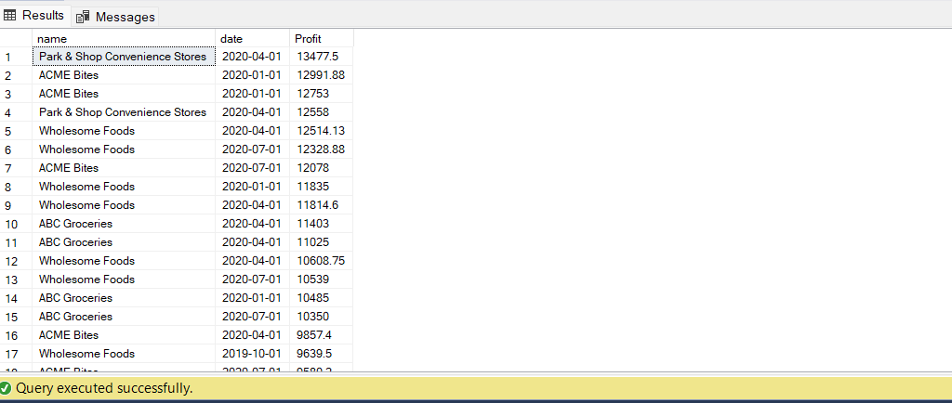

--write a query to find the percentage of revenue contributed by each cookie type to the total revenue.

select

Cookie_Type,cast(Cost_Per_Cookie*100/Revenue_Per_Cookie as decimal(10,2)) as Percentage_of_Revenue

from [Cookie Types]

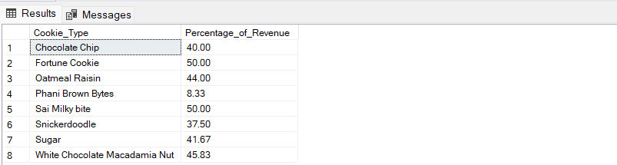

--calculate the total revenue and total cost for each product for the current year

select

year(Date) as yearr,Product,sum(Revenue) as 'Total Revenue',sum(cost) as 'Total Cost'

from orders

where year(date) = 2020

group by product,year(date)

order by [Total Revenue] desc

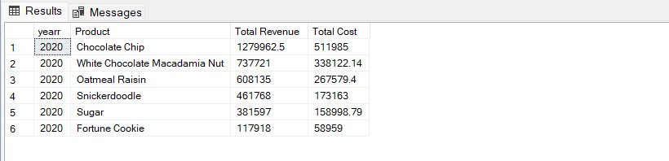

--find the customer who made the highest number of orders and the total amount spent by that customer.

select top 1 c.name ,count(o.order_id) as 'Total Orders'

from customers as c join Orders as o

on o.Customer_ID = c.Customer_ID

group by c.name

order by [Total Orders] desc;

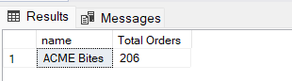

-- determine the average units sold per order for each product.

select product,cast(avg(units_sold) as decimal(10,2)) as 'Avg Units Sold'

from orders

group by product

order by [Avg Units Sold] desc

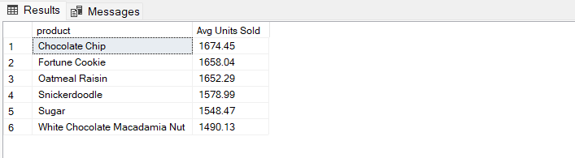

--5. write a query to find the top 5 customers who spent the most on cookie orders.

select c.name,sum(o.Revenue) 'Total Orders'

from customers as c join orders as o

on c.Customer_ID = o.Customer_ID

group by c.name

order by [Total Orders] desc

